Assignment – 1

Name: MD AMAN

Hall Ticket No. : 2303A510C0

Batch No. : 06

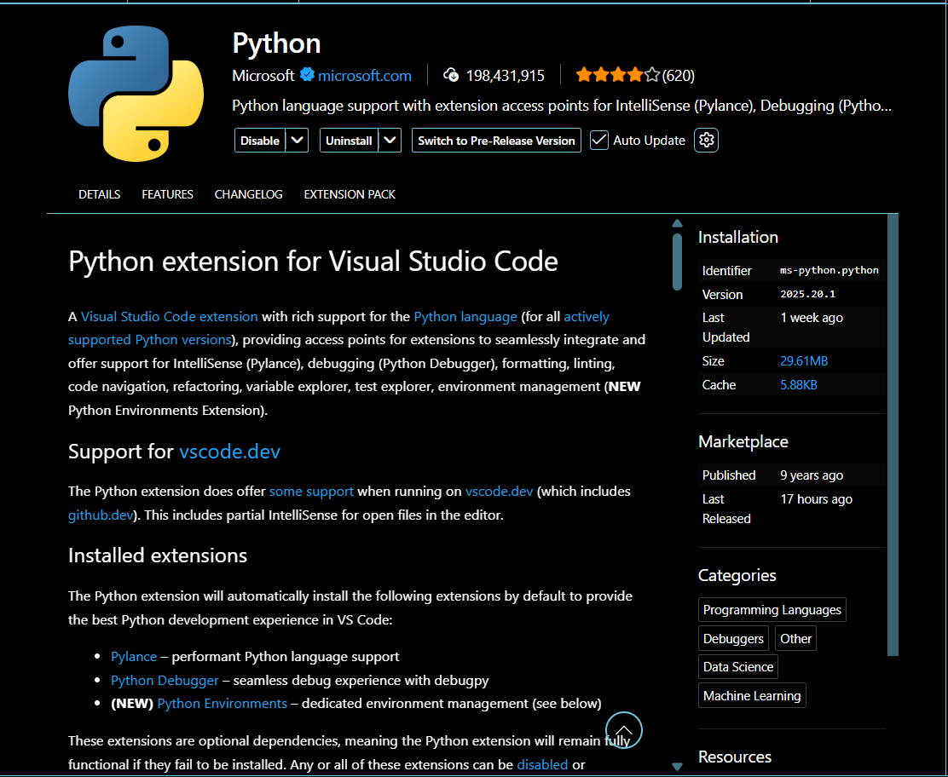

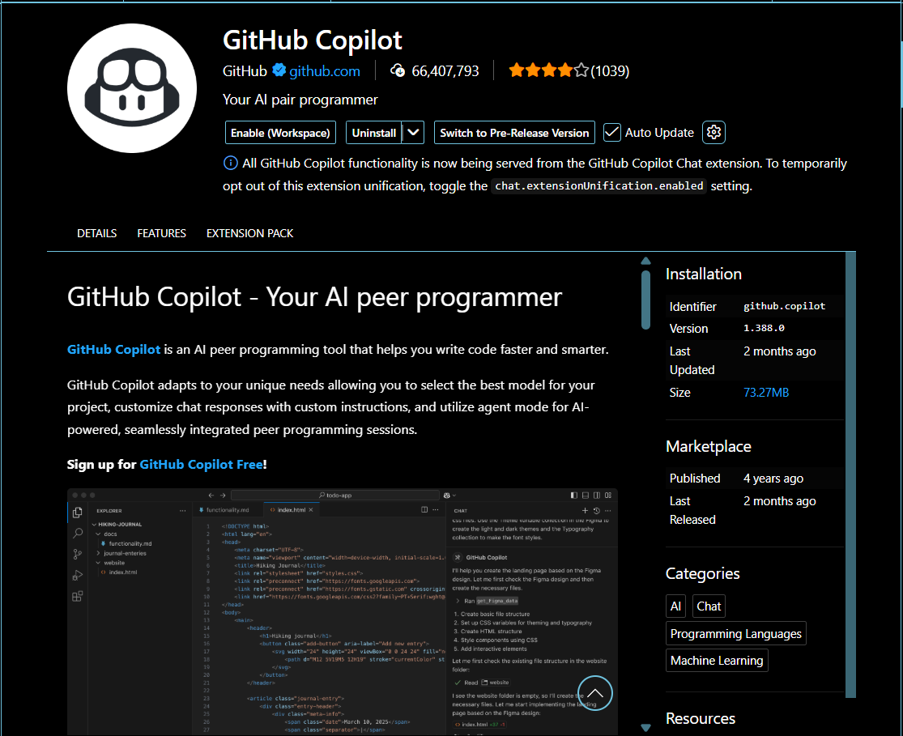

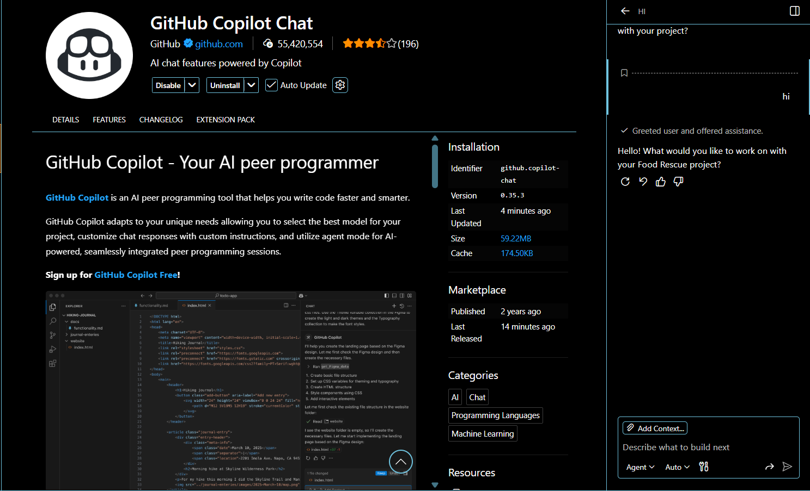

#Task 1
Prompt: #Fibinocci Series without Functions and logic should be in main code body
Code:
n = int(input("Enter the number of terms in Fibonacci series: "))
a, b = 0, 1
print("Fibonacci Series:")
#handleing edge cases
if n <= 0:
print("Please enter a positive integer.")
elif n == 1:
print(a)
else:
print(a)
print(b)
for _ in range(2, n):
c = a + b
print(c)
a, b = b, c

Output :

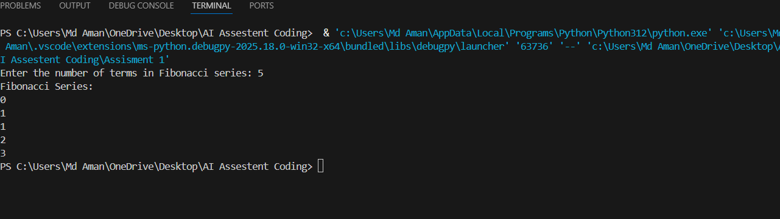

Explanation : The algorithm starts with the first two numbers of the Fibonacci sequence, which are 0 and 1."This loop is set to run 'n' times." Every successive number is found by adding the two numbers prior to it. The logic is directly coded within the main code body. It is not made modular. This method is fast but cannot be reused in bigger applications.

#Task 2
Prompt: #Optimize the code in shorter form
Code:
n = int(input("Enter the number of terms in Fibonacci series: "))
if n <= 0:
print("Please enter a positive integer.")
else:
a, b = 0, 1
print("Fibonacci Series:")
for i in range(n):
print(a)
a, b = b, a + b

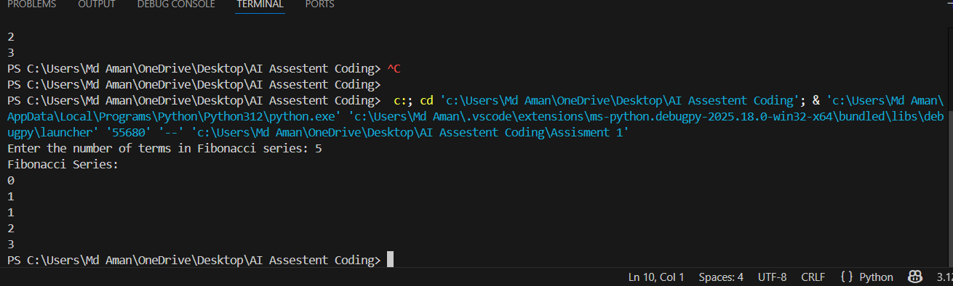

Explanation : Inefficient- Additional and not altogether necessary conditional tests. Slightly verbose variable handling. Messages for simple logic – redundancy.
Optimized - Fewer number of conditions. Cleaned up and legible loop code. Same output with reduced structure. More understandable and maintainable for programmers.

#Task 3
Prompt: #Fibinocci Series with functions
Code:
def fibonacci(n):
a, b = 0, 1
series = []
for _ in range(n):
series.append(a)
a, b = b, a + b
return series
num_terms = int(input("Enter the number of terms in the Fibonacci series: "))
fib_series = fibonacci(num_terms)
print("Fibonacci series:")
for num in fib_series:
print(num, end=' ')

Output :

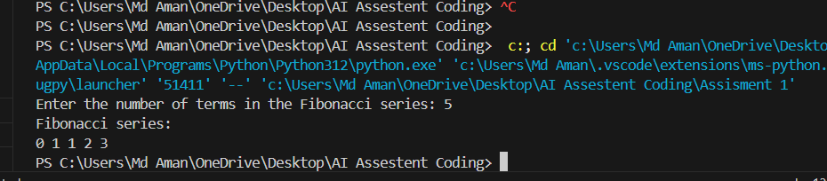

Explanation : Logic is encapsulated inside a function. The function returns the Fibonacci series up to the given number as a list. Improves code reuse, testing, and readability. Suitable for large and modular applications.

#Task 4
Prompt : #Compare the two methods and give differences
#print the differences
# Description on comparision between with functions and without functions
Code :
#Fibonacci Series without functions
n = int(input("Enter the number of terms in the Fibonacci series: "))
a, b = 0, 1
print("Fibonacci series:")
for _ in range(n):
print(a, end=' ')
a, b = b, a + b
print("\n")

#Fibinocci Series with functions
def fibonacci(n):
a, b = 0, 1
series = []
for _ in range(n):
series.append(a)
a, b = b, a + b
return series
num_terms = int(input("Enter the number of terms in the Fibonacci series: "))
fib_series = fibonacci(num_terms)
print("Fibonacci series:")
for num in fib_series:
print(num, end=' ')

#Compare the two methods and give differences
#print the differences
print("\n\nDifferences between the two methods:")
print("1. The first method does not use functions, while the second method encapsulates the logic in a function.")
print("2. The first method prints the series directly, while the second method returns a list of Fibonacci numbers.")
# Description on comparision between with functions and without functions
print("3. The function-based approach is more reusable and modular, allowing for easier testing and maintenance.")

Tabular Format:
Feature | Without Functions | With Functions
Code Clarity | Moderate | High
Reusability | No | Yes
Debugging | Difficult | Easy
Scalability | Poor | Excellent
Suitability for Large Systems | Low | High
Output :

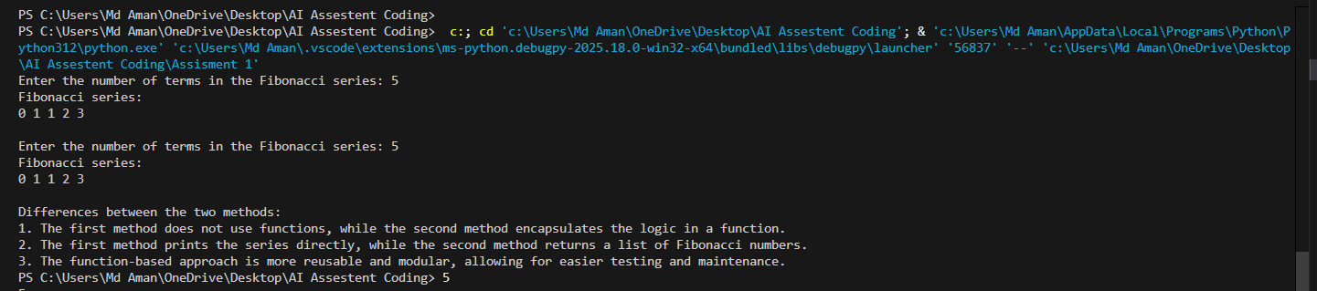

Explanation : Analysis -Procedural code is simpler to write but nastier to maintain. Function-oriented code is more cleanable. In real-world software development, it is preferred to be modular.

#Task 5
Prompt : #fibanocci series using different algorithms or Recursion or Iteration or Dynamic Programming
Code :
# Function to generate Fibonacci series using recursion
def fibonacci_recursive(n):
if n <= 0:
return []
elif n == 1:
return [0]
elif n == 2:
return [0, 1]
else:
series = fibonacci_recursive(n - 1)
series.append(series[-1] + series[-2])
return series
# Function to generate Fibonacci series using iteration
def fibonacci_iterative(n):
series = []
a, b = 0, 1
for _ in range(n):
series.append(a)
a, b = b, a + b
return series
# Function to generate Fibonacci series using dynamic programming
def fibonacci_dynamic(n):
if n <= 0:
return []
series = [0] * n
series[0] = 0
if n > 1:
series[1] = 1
for i in range(2, n):
series[i] = series[i - 1] + series[i - 2]
return series
# Example usage
n = int(input("Enter the number of terms in Fibonacci series: "))
print("Fibonacci series using recursion:", fibonacci_recursive(n))
print("Fibonacci series using iteration:", fibonacci_iterative(n))
print("Fibonacci series using dynamic programming:", fibonacci_dynamic(n))

Output :

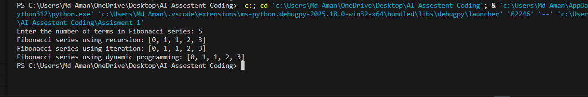
Explanation :
Iterative: Iterative solutions employ the use of loops to work with different values.
Recursive: It calls itself within its own definition.
The iterative method is efficient. Recursion is good for learning, but not very efficient. For large inputs, recursion should not be used.

